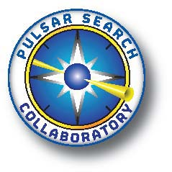
Calling Teachers and Students:
Join the Pulsar Search Collaboratory

West Virginia University (WVU) and the Green Bank Observatory (GBO) cordially invite you and your students to collaborate with us in the grand adventure of scientific discovery!

How? By joining the Pulsar Search Collaboratory (PSC). Students and teachers in school-based PSC teams:
- Gain first-hand experience in conducting scientific research;
- Improve their 21st Century Skills;
- Learn more about Science, Mathematics, Technology and Engineering (STEM) careers;
- Help astronomers search the Galaxy for new pulsars!
Check out our webpage at: http://pulsarsearchcollaboratory.com

PSC Background

Did you know that the GBO operates the world’s largest fully steerable dish, the Green Bank Telescope (GBT), in Green Bank, WV? Because of its sensitivity, this radio telescope is very important to scientists worldwide.

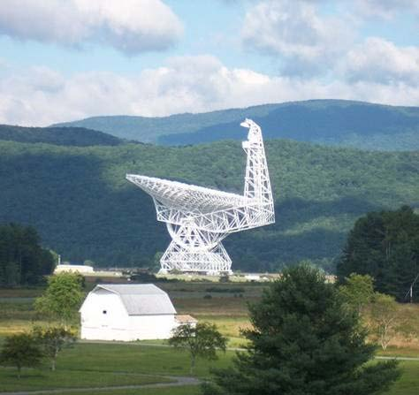
In summer of 2007, the GBT was “immobilized” to enable GBO to replace the track on which the 17 million pound structure rotates. Obviously, since the telescope couldn’t pivot, the kinds of experiments that could be done were extremely limited. But, an international group of scientists had an idea. They would use the telescope to survey the sky for new pulsars--rapidly rotating stellar corpses that emit radio waves. Over the summer, this team surveyed over 25% of the sky and amassed 130 TERABYTES of data.
Green Bank Telescope

That’s a lot of data. We thought: with mountains of data to explore, and new discoveries to be made, why not involve teachers and high school students in the search? The National Science Foundation thought it was a good idea too, and in 2008 they awarded a grant to GBO and WVU. And the PSC was born! In the years since that first drift scan survey, many more giant surveys have been undertaken resulting in more data. In 2015, we received another grant to expand the PSC to 13 hubs around the country and we accumulated 375 hours of GBT time (and over 35 Terabytes of data) for drift scan survey using the 820-MHz receiver.

PSC Project Information
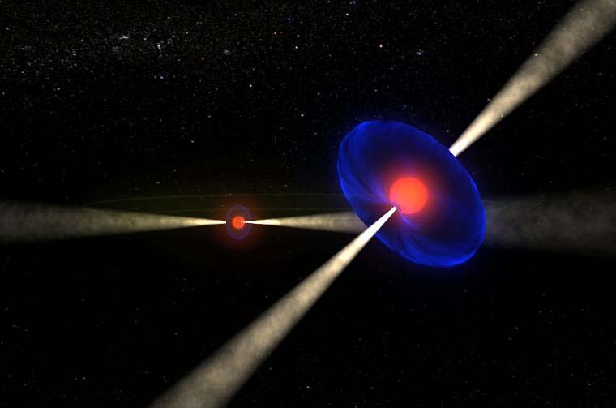
- Teachers may be science/math teachers teaching grades 8-12.
- Multiple teachers from the same school are encouraged to apply.
Unique Double Pulsar System discovered by astronomers involved in the PSC!

- Motivated students can apply without a participating teacher.
- For the training, you need access to a computer on the internet (not a tablet or phone).
Unique double pulsar system discovered by PSC astronomers!

Astronomy knowledge is not a prerequisite for participation! But a desire to involve yourself and your students in research is! Go here to complete an online application: http://pulsarsearchcollaboratory.com/teacherapp/

Program Components:

1. Free Workshops for teachers and students. In order to be selected by the PSC, you must be willing to complete six online sessions to gain background knowledge and familiarity with pulsar data. You will need access to the internet in order to attend the sessions and to complete homework.
2. Online community. Teachers and students can post interesting data, and ask the experts questions any time using the PSC website! Pulsar astronomers and others will lead online classes on topics ranging from basic astronomy content to Q/A sessions with you and your students on pulsars and pulsar data to discussions about post-high school education options, applying for college.
3. Capstone Seminar. In May, PSC teams will share the results of their research with each other at a Capstone Seminar. Plans are underway to hold Capstone at a hub institution near you. Students and teachers who are active participants in the PSC will be eligible to attend.
4. PSC Camp. Active PSC teachers and students may apply to PSC camp at the National Radio Astronomy Observatory in Green Bank, WV! Work alongside astronomers to learn how to characterize pulsars! Up to 20 teachers, 40 students and 16 undergraduate students will be selected. Travel, room and board are covered.

Teacher Responsibilities:

- Sign students up to form a PSC team at your school. These students will participate in the online workshop as well. Once team members pass two data analysis “tests” they will be granted access to the database and can begin searching real data!
- Communicate with PSC staff and student mentors to set up real or virtual meetings with your team.
- Oversee the teams—make sure that teams are meeting and working on data—often this occurs after school or during “club” time.
- Assist in preparing students for Capstone.

Additional Teacher and Student Benefits:

- Teachers will receive a $500 stipend for participating in the summer camp experience.
- Teachers may elect to receive three hours of Graduate Credit in astronomy (optional) through West Virginia University (admission and off campus fees add up to about $230).
- Students who remain active in the PSC for two years may receive three hours of undergraduate credit for around $180 through WVU (restrictions apply).
- You get the satisfaction of participating in real science!

Relevance of the PSC to Next Generation Science Standards

1. Nature of Science/Science as Inquiry. The PSC provides students with experience in conducting scientific research. At the same time, core content can be introduced. The PSC integrates the teaching of the facts of science with the practice of scientific research.
2. Content. Pulsars, rapidly spinning highly magnetized neutron stars, are fascinating objects for study. Research into their extreme properties has impacted most areas of fundamental physics. The PSC will allow students to gain first-hand insights into several areas of the NGSS Physical Science Content Standards including: Motions and forces, Conservation of energy, Interactions of energy and matter.
3. 21st Century skills. The PSC requires students to work in teams, to communicate their results to one another and to use technology to improve their ability to do science.

Have Questions? Need more information? Contact:

- Sue Ann Heatherly (at GBO): sheather@nrao.edu
- Maura McLaughlin (at WVU): maura.mclaughlin@mail.wvu.edu
- Harsha Blumer (at WVU): harsha.blumer@mail.wvu.edu

